**Codon Adaptation Index (CAI):**

The Codon Adaptation index uses a reference set of highly expressed genes from a specific species, to assess the relative frequency of each codon with respect to its synonymous codons and the total score for the gene [1]. The calculation is performed according to the following algorithm:

1. Calculation of the weight for each codon – based on a reference set a weight is given for each codon in a range of (0, 1], when weight of 1 indicates to an optimal codon. The formula is:

()

The weight of the i_th codon of amino acid x is equal to the number of appearances of codon i (xi) dividing with the number of appearances of the most common codon (out of the synonymous codons of amino acid x) .

(*) CAI is not calculated for start and stop codons.

1. Scoring – The geometric mean of the codons' weights is calculated to get the CAI score of the gene. It is given by:

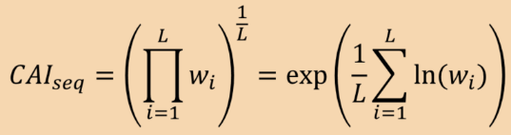()

When L is the gene length (according to codons count).

Multiplication of many numbers in a range of (0, 1] can produce very low score, and as a result to cause an underflow, so the computer will recognize the score wrongly as 0. To deal with this problem we use 'exp' and 'ln' functions in order to convert the multiplication into a sum [2].

יצא מצב שהמשקל של קודון היה 0?

**Wobble Hypothesis:**

The Wobble hypothesis proposes that normal base pairing (Watson-Crick) can occur between the first and second bases of the codon to the third and second bases of the anticodon, respectively. However, the first base of the anticodon may be bound to the third base of the codon also with Wobble interactions, which does not require a perfect match. In that way, each tRNA can interact with more than one codon, and each codon can be bound by more than one tRNA. It should be mentioned that the affinity of Wobble interactions is lower than Watson-Crick [3].

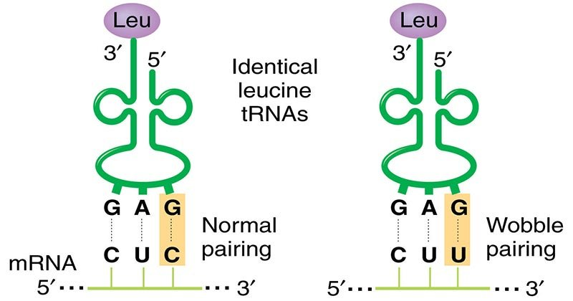

**Figure ()** The same tRNA can interact with CUC codon by Watson-Crick base pairing (left), and to CUU codon by Wobble interactions (right) [4].

**tRNA Adaptation Index (tAI):**

The tRNA Adaptation Index is a measure of translational efficiency which considers the intracellular concentration of tRNA molecules and the affinity of each codon–anticodon pairing. This index is calculated based on a reference set of highly expressed genes from a specific species, since highly expressed genes tend to have higher codon usage bias (CUB) and higher adaptation to the tRNA pool [5]. The score of a gene is in a range of (0, 1], when score of 1 is given to an optimal gene which is recognized by a lot of tRNAs with high affinity. The calculation is performed according to the following algorithm [6]:

1. Estimation of tRNA pool distribution – In order to get tRNA pool distribution, tRNA levels should be measured directly. This process is very complicated, so the distribution is usually calculated based on tRNA gene copy number. Unlike most of the genes, tRNA genes appear more than once in the genome due to their critic role.
2. Calculation of the weight for each codon - the translational efficiency of the i-th codon (out of 61 possible codons) is given by:

where n_i is the number of tRNA types that pair with the i_th codon, tGCN_j is the tRNA_j gene copy number, S_ij is a value between 0 and 1 representing the affinity of the pairing between the i_th codon and the j_th tRNA (a value closer to zero indicates more efficient wobble interaction), and W_i is the weight of the i_th codon.

1. Normalization - Normalized weights are given by:

()

w_i is obtained by dividing W_i by the maximum weight among all 61 codons, zero Wi weights are set to the geometric mean among the other weights.

1. Scoring – gene score is calculated by the geometric mean of all the codon weights, given by:

()

[1]. Paul M. Sharp, Wen-Hsiung Li, The codon adaptation index-a measure of directional synonymous codon usage bias, and its potential applications, *Nucleic Acids Research*, Volume 15, Issue 3, 11 February 1987, Pages 1281–1295, <https://doi.org/10.1093/nar/15.3.1281>

[2]. A. Carbone, A. Zinovyev, F. Képès. Codon adaptation index as a measure of dominating codon bias, *Bioinformatics*, Volume 19, Issue 16, 1 November 2003, Pages 2005–2015, <https://doi.org/10.1093/bioinformatics/btg272>

[3]. Peretó J. (2011) Wobble Hypothesis (Genetics). In: Gargaud M. et al. (eds) Encyclopedia of Astrobiology. Springer, Berlin, Heidelberg. <https://doi.org/10.1007/978-3-642-11274-4_1692>

[4]. Verma, P. S., & Agrawal, V. K. (2006). Cell Biology, Genetics, Molecular Biology, Evolution & Ecology (1 ed.). S .Chand and company Ltd.

[5]. Sabi, R., Volvovitch Daniel, R., Tuller, T. stAIcalc: tRNA adaptation index calculator based on species-specific weights, *Bioinformatics*, Volume 33, Issue 4, 15 February 2017, Pages 589–591, <https://doi.org/10.1093/bioinformatics/btw647>

[6]. dos Reis, M., Savva, R., & Wernisch, L. (2004). Solving the riddle of codon usage preferences: a test for translational selection. Nucleic acids research, 32(17), 5036–5044. https://doi.org/10.1093/nar/gkh834